Day 1 - yokeshmb - Yokesh M

**Question1 :** What is SDLC ?

It is a structured process for planning, creating, testing, deploying and maintaining software systems. It provides a systematic approach to software development to ensure quality, efficiency and alignment with requirements.

**Question 2 :** Why is SDLC ?

1. Structured Approach
2. Quality Assurance and on time delivery
3. Risk Management
4. Time Efficiency and best customer experience
5. Simplifies Maintenance and Scalability

**Question 3 :** What are the stages of SDLC ?

There 7 different stages

1. Planning
2. Requirement analysis
3. Design
4. Development
5. Testing
6. Deployment
7. Maintenance

**Question 4:** SDLC Models

1. Waterfall - Linear, sequential phases. Ideal for the projects with stable requirements.

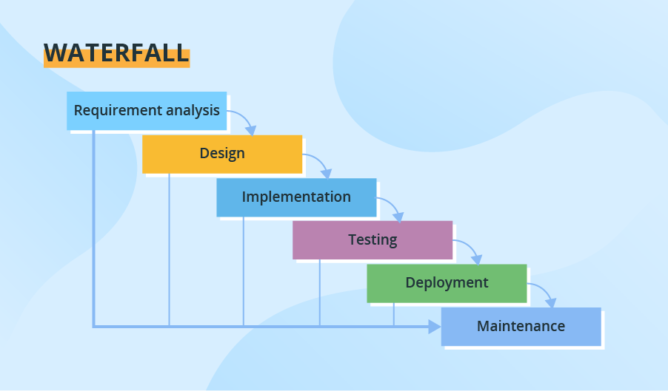

1. Agile - Iterative, incremental approach with frequent feedback, suits dynamic projects

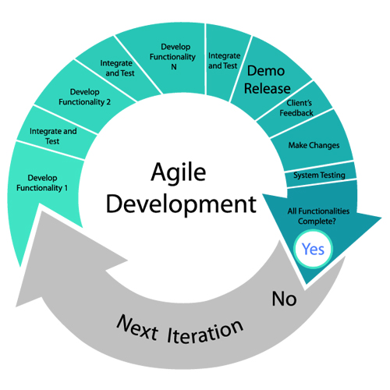

1. Scrum - A subset of agile with short sprints and regular team collaboration

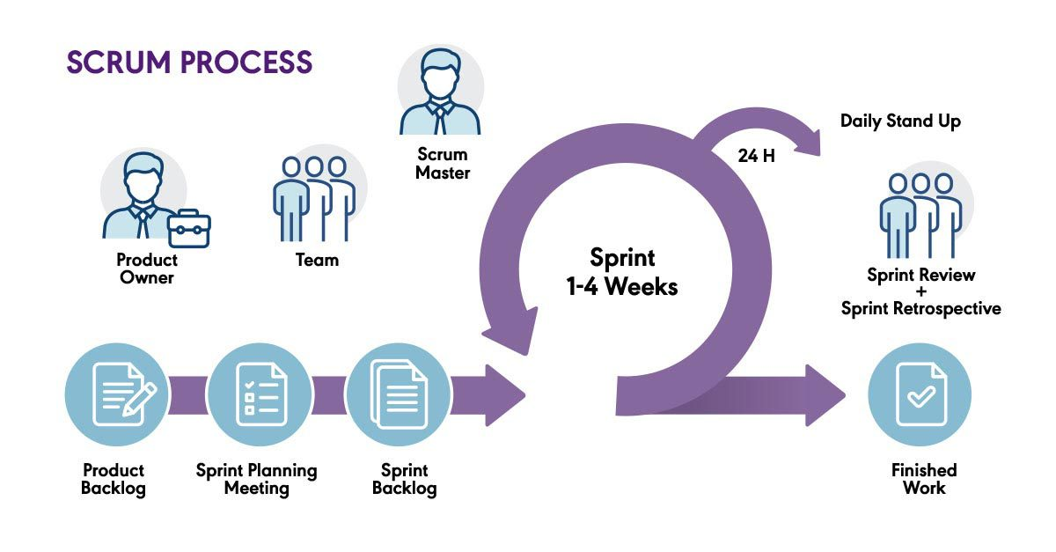

1. Spiral - Combines iterative development with risk analysis used for large,complex projects

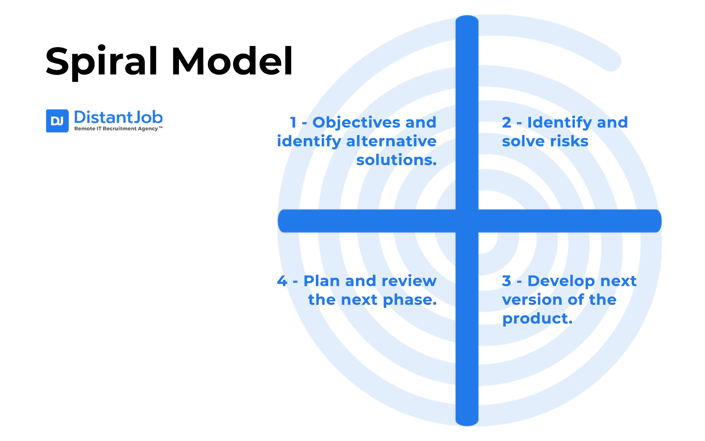

1. Devops - integrates development and operations for continuous integration ad delivery

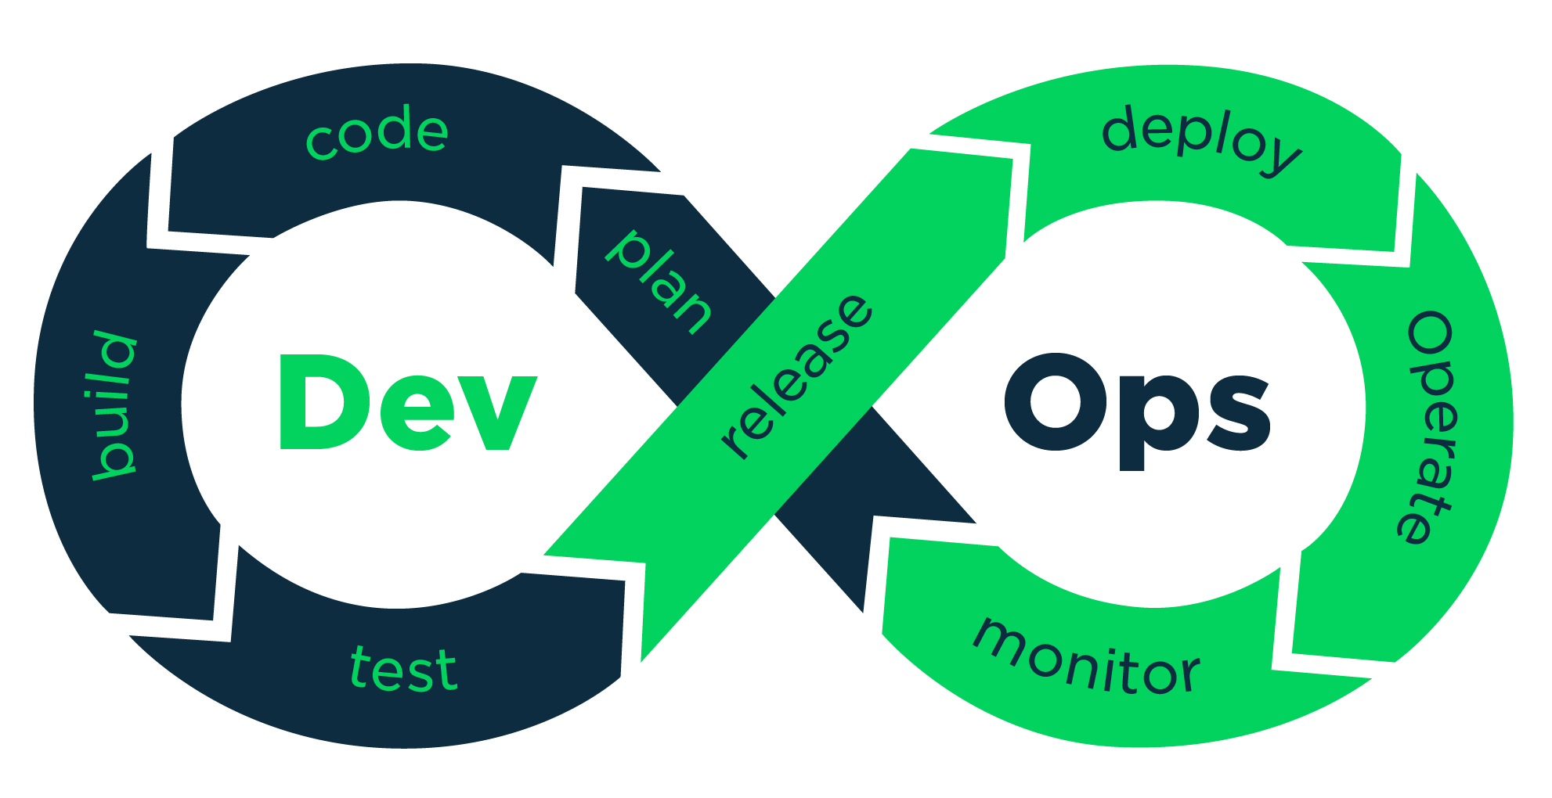

**Question 5 :** What are different network types ?

1. LAN - Local Area Network
2. WAN - Wide Area Network
3. MAN - Metropolitan Area Network
4. PAN - Personal Area Network
5. VPN - Virtual Private Network
6. SAN - Storage Area Network
7. CAN - Campus Area Network
8. HAN - Home Area Network

**Question 6 :** What are the types of servers ?

1. Web server - Hosts and delivers web content to clients via HTTP/HTTPS
2. Application Server - Hosts and executes business logic or applications, often serving as a middle tier between clients and databases
3. Database Server - Manages and provides access to databases, handling data storage, retrieval and queries
4. File Server - Stores and manages files providing shared access to clients over a network
5. Mail Server - Handles sending, receiving and storing email messages using protocols
6. DNS Server - Domain name server translates domain into ip addresses for network communication
7. Proxy server - acts as a intermediary between clients and other servers often to security, caching or anonymity
8. Virtual machine server - Hosts multiple virtual machines on a single physical server, enabling resources sharing

**Question 7 :** What is DNS ?

Verbal test explained in the call.

**Question 8 :** What is TCP and UDP ? what is the difference

TCP : Transmission Control Protocol

It is a reliable, connection-oriented protocol that ensures data is delivered accurately, in order and without loss

UDP : User Datagram Protocol

It is a fast, connectionless protocol that prioritizes speed over reliability, sending data without guaranteeing delivery

Difference between TCP and UDP

| Feature | TCP | UDP |
| --- | --- | --- |
| Connection | Connection-oriented | Connectionless |
| Reliability | Reliable(acknowledgment, retransmissions) | Unreliable (no guarantees) |
| Speed | Slower | Faster |
| Ordering | Ensures correct packet order | No order guarantee |
| Flow/congestion control | Yes (prevents Network overload) | No (can cause congestion) |
| Use Cases | Web, email, file transfer, databases | Streaming, gaming, DNS |
| SDLC Imapct | Critical for reliable apps | Critical for real-time apps |

**Question 9:** What do you know about mac address ? What is the difference between Mac address and IP address.

Mac Address : Media Access Control address is a unique identifier assigned to a network interface controller (NIC) for use as network address in communication within a network segment. It is a 48-bit address, typically represented a six groups of hexadecimal digits.

Difference between :

| Aspect | MAC Address | IP Address |
| --- | --- | --- |
| Definition | Unique identifier for a network interface controller (NIC) at the hardware level. | Logical address assigned to a device for network communication |
| Layer | Operates at data link layer (layer 2) | Operates at network layer (layer 3) |
| Format | 48- bit hexadecimal | 32 bit decimal numbers IPV4 |

**Question 10 :** What is OSI model ?

The OSI (open system interconnection)model is a conceptual framework used to understand and standardise network communication. It has seven distinct layers of network communication. Each has the specific data transmission.

1. Physical layer
2. Data Link layer
3. Network layer
4. Transport layer
5. Session layer
6. Presentation layer
7. Application layer

### Physical layer

The physical layer refers to the physical communication medium and the technologies to transmit data across that medium. At its core, data communication is the transfer of digital and electronic signals through various physical channels like fiber-optic cables, copper cabling, and air. The physical layer includes standards for technologies and metrics closely related with the channels, such as Bluetooth, NFC, and data transmission speeds.

### Data link layer

The data link layer refers to the technologies used to connect two machines across a network where the physical layer already exists. It manages data frames, which are digital signals encapsulated into data packets. Flow control and error control of data are often key focuses of the data link layer. Ethernet is an example of a standard at this level. The data link layer is often split into two sub-layers: the Media Access Control (MAC) layer and Logical Link Control (LLC) layer.

### Network layer

The network layer is concerned with concepts such as routing, forwarding, and addressing across a dispersed network or multiple connected networks of nodes or machines. The network layer may also manage flow control. Across the internet, the Internet Protocol v4 (IPv4) and ipv6 are used as the main network layer protocols.

### Transport layer

The primary focus of the transport layer is to ensure that data packets arrive in the right order, without losses or errors, or can be seamlessly recovered if required. Flow control, along with error control, is often a focus at the transport layer. At this layer, commonly used protocols include the Transmission Control Protocol (TCP), a near-lossless connection-based protocol, and the User Datagram Protocol (UDP), a lossy connectionless protocol. TCP is commonly used where all data must be intact (e.g. file share), whereas UDP is used when retaining all packets is less critical (e.g. video streaming).

### Session layer

The session layer is responsible for network coordination between two separate applications in a session. A session manages the beginning and ending of a one-to-one application connection and synchronization conflicts. [Network File System (NFS) and Server Message Block (SMB)](https://aws.amazon.com/compare/the-difference-between-nfs-smb/) are commonly used protocols at the session layer.

### Presentation layer

The presentation layer is primarily concerned with the syntax of the data itself for applications to send and consume. For example, [Hypertext Markup Language (HTML)](https://aws.amazon.com/compare/the-difference-between-html-and-xml/), [JavaScipt Object Notation (JSON)](https://aws.amazon.com/documentdb/what-is-json/), and Comma Separated Values (CSV) are all modeling languages to describe the structure of data at the presentation layer.

### Application layer

The application layer is concerned with the specific type of application itself and its standardized communication methods. For example, browsers can communicate using HyperText Transfer Protocol Secure (HTTPS), and HTTP and email clients can communicate using POP3 (Post Office Protocol version 3) and SMTP (Simple Mail Transfer Protocol).

**Question 11 :** What is an IPv4 address? What are the different classes of IPv4?

An IPv4 address is a 32-bit numerical address used to identify devices on a network. These addresses are typically represented in a dotted decimal format, like 192.168.1.1, where each number represents a group of 8 bits (an octet). IPv4 addresses are divided into five classes (A, B, C, D, and E) based on their first octet, with each class having a different default subnet mask and intended usage.

Classes of IPv4 Addresses:

* Class A:  
  0-127.0.0.0 to 127.255.255.255 (Large networks, 8-bit network ID, 24-bit host ID)
* Class B:  
  128-191.0.0.0 to 128.255.255.255 (Medium-sized networks, 16-bit network ID, 16-bit host ID)
* Class C:  
  192-223.0.0.0 to 223.255.255.255 (Small networks, 24-bit network ID, 8-bit host ID)
* Class D:  
  224-239.0.0.0 to 239.255.255.255 (Multicast addressing, used for sending data to multiple hosts simultaneously)
* Class E:  
  240-255.0.0.0 to 255.255.255.255 (Experimental, reserved for research)

In simpler terms:

* A, B, and C: These are the most common classes used for public and private IP addresses, with A being the largest and C the smallest.
* D: Used for sending the same information to multiple computers on a network simultaneously.
* E: Reserved for experimental use.

**Question 12:** What is VPN and advantages of VPN ?

A Virtual Private Network (VPN) is an encrypted connection that creates a secure tunnel between a device and a server, masking the user's IP address and location. This provides several advantages, including enhanced privacy, security, and access to region-specific content.

Advantages of Using a VPN:

* Enhanced Privacy:  
  VPNs help hide browsing activity, location, and other personal information from third-party tracking.
* Increased Security:  
  Encryption protects data transmitted over public Wi-Fi networks and other insecure connections.
* Access to Geo-Restricted Content:  
  VPNs can make it appear as if a user is browsing from a different location, allowing access to content that may be restricted in their actual region.
* Protecting Against Throttling:  
  VPNs can bypass throttling, a practice used by Internet Service Providers (ISPs) to slow down internet speeds.

**Question 13:**

Types of VPN:

* Remote Access VPN
* Site to site vpn
* Intranet VPN
* Extranet VPN

#### 1. Remote Access VPN:

Remote Access VPN permits a user to connect to a private network and access all its services and resources remotely.

2. Site to Site VPN :

A Site-to-Site VPN is also called a Router-to-Router VPN and is commonly used in large companies. Companies or organizations, with branch offices in different locations, use Site-to-site VPN to connect the network of one office location to the network at another office location

3.Intranet based VPN: When several offices of the same company are connected using Site-to-Site VPN type, it is called an Intranet based VPN.

4.Extranet based VPN: When companies use Site-to-site VPN type to connect to the office of another company, it is called Extranet based VPN.

**Question 14 :** Node and link

**Question 15:** Topology means

**Question 16 :** What is different types of network topology

* Bus Topology: All devices share a single communication line, with data traveling in one direction.

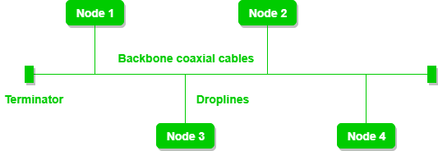

* Ring Topology: Devices are connected in a circular manner, with data traveling in a unidirectional or bidirectional loop.

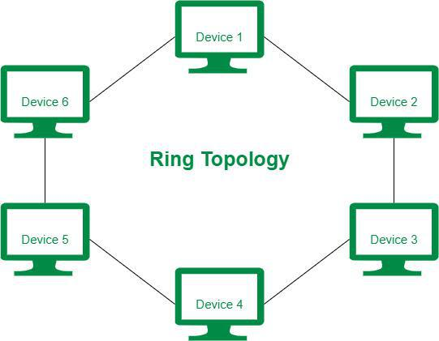

* Star Topology: All devices are connected to a central hub or switch, which mediates communication.

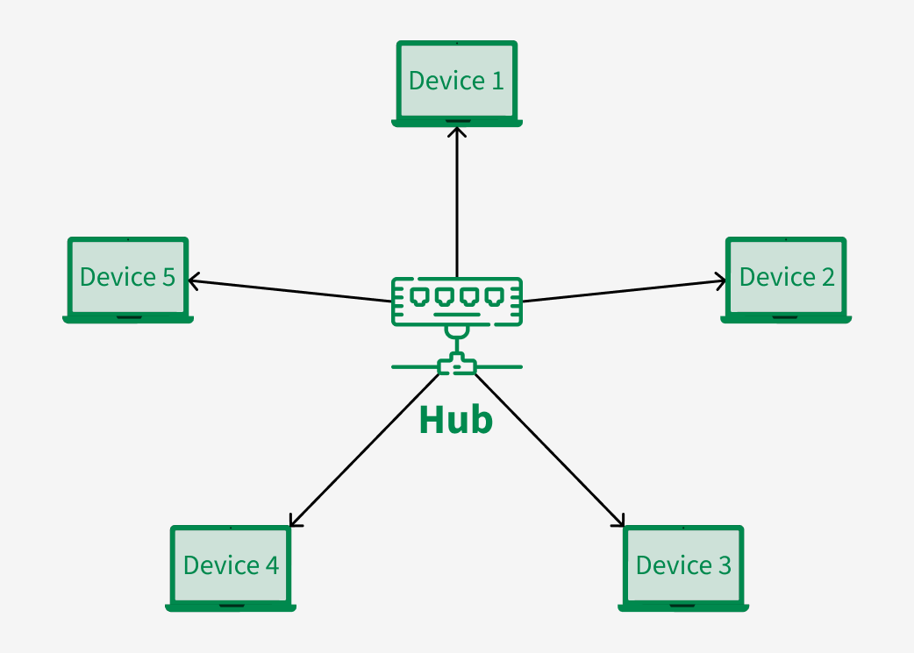

* Mesh Topology: Every device is directly connected to every other device, providing multiple communication paths.

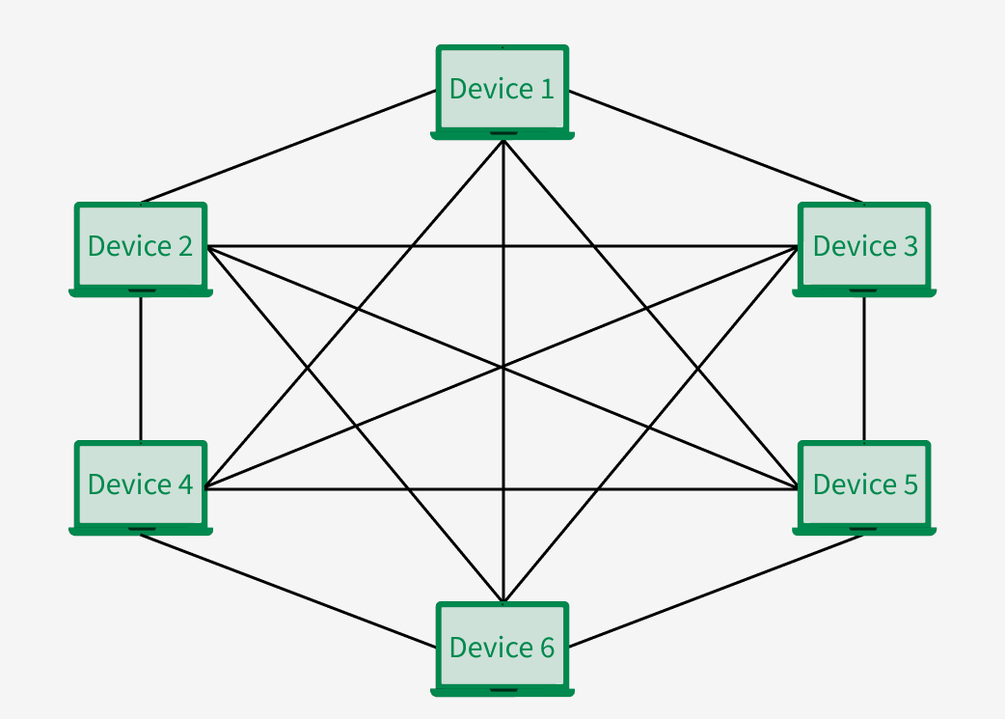

* Tree Topology: A hierarchical structure that combines multiple star topologies connected to a central bus-like backbone.

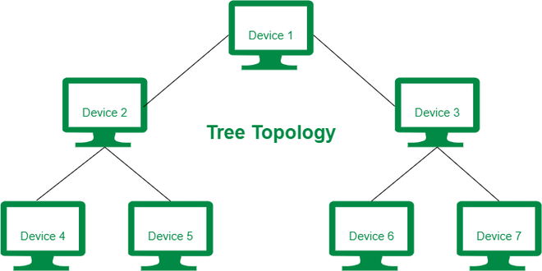

* Hybrid Topology: A combination of two or more different topologies to meet specific needs.

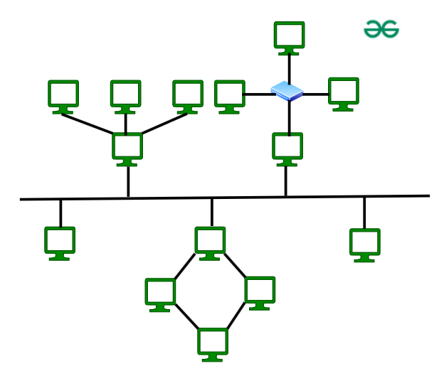

* Point-to-Point Topology: Two devices are directly connected by a dedicated communication link.

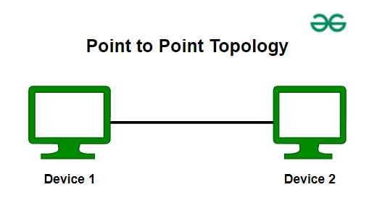

**Question 17:**

What is extended bus topology ? its Tree Topology.

**Question 18:** What is the use of a router and how is it different from a gateway?

Router: Primarily routes traffic between networks using IP addresses, typically for internal networks (like LAN to WAN).

Gateway: Acts as a bridge for different networks, often converting between different protocols or communication methods.

**Question 19**: What is SMTP ?

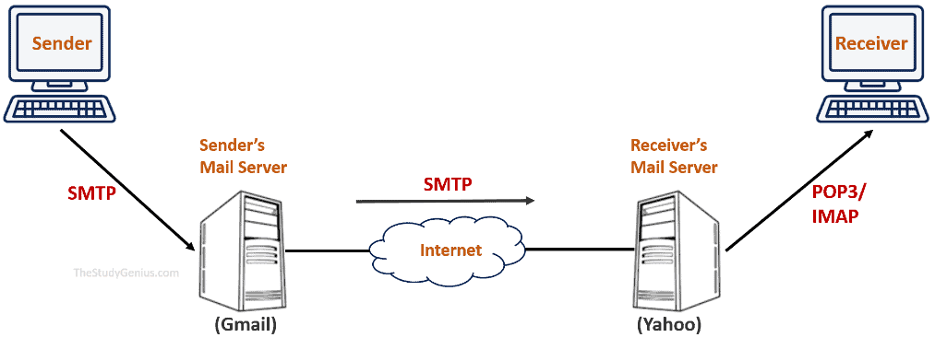

Simple Mail Transfer Protocol, is a standard communication protocol used for sending and receiving emails over a network. It's essentially the technology that allows you to send an email from one computer to another. SMTP works at the application layer of the TCP/IP protocol stack

**Question 20:** Differentiate between OSI and TCP/IP

| **Aspect** | **OSI Model** | **TCP/IP Model** |
| --- | --- | --- |
| **Number of Layers** | 7 | 4 |
| **Layer Names** | 1. Physical 2. Data Link 3. Network 4. Transport 5. Session 6. Presentation 7. Application | 1. Link (Network Interface) 2. Internet 3. Transport 4. Application |
| **Purpose** | A conceptual framework designed to guide the development of network communication standards. | A practical model that defines protocols for communication over the internet and networks. |
| **Functionality** | Provides a more granular breakdown of functions, with each layer having specific roles. | Fewer layers, combining functions of multiple layers from the OSI model into broader categories. |
| **Protocol Specification** | Does not define specific protocols but provides guidelines for protocol development. | Specifies actual protocols used for communication, such as TCP, IP, HTTP, etc. |
| **Usage** | Used primarily as an educational tool or a conceptual reference for understanding network communication. | Used in real-world networking, forming the foundation of the internet and modern networking protocols. |
| **Layer Interaction** | More detailed and isolated layer interactions — each layer has distinct responsibilities. | Broader layer interactions where some layers combine functions from the OSI model. |
| **Layer Functions** | Each layer of the OSI model performs specific tasks like data encoding, error detection, and routing. | Fewer layers handle a broader range of tasks, such as IP addressing (Internet layer) and data transmission (Transport layer). |
| **Examples** | Conceptual model with no direct implementation; used as a reference in network design. | Real-world application with actual implementation protocols such as TCP, IP, HTTP, FTP used in modern networks. |

**Question 21:**

HTTP and HTTPs

Oral

**Question 22:**

What is HLD?

It is an overview or blueprint of the system. It provides a general description of the system architecture, major components, and how they interact with each other.

What is LLD ?

It is a detailed design that breaks down the components described in the HLD. It focuses on the internal structure and specific technical details of each module.

**Question 23:** What is SRS ?

An SRS (Software Requirements Specification) is a document that provides a detailed description of the software system to be developed. It outlines the functional and nonfunctional requirements, as well as the system's behavior, features, and constraints. The SRS serves as a foundation for the design, development, and testing phases in the Software Development Life Cycle (SDLC).

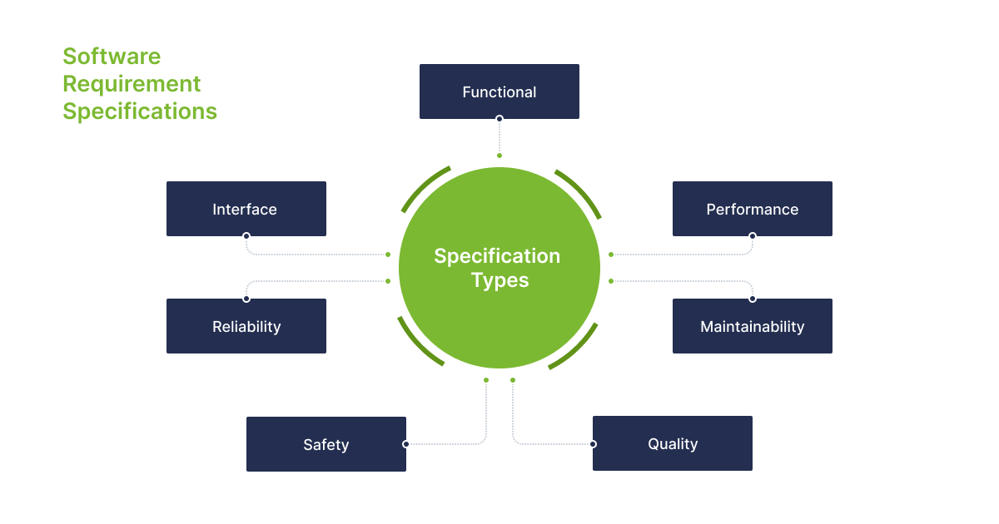

## **SDLC MCQ**

1.

A feasibility study using the SDLC model is conducted to

determine whether or not the project is technically possible

determine whether the proposal is financially viable

Both a and b

None of the above

2.

A well-documented life cycle model aids in the detection of what during the development phase?

Inconsistencies

Redundancies

Omission

All of the above

3.

How many lines of code does the Build & Fix Model suit for programming exercises?

100-200

300-400

600-700

Above 800+

4.

In which life cycle does regression testing play a significant role?

Waterfall model

V model

Iterative model

All of the above

5.

What determines if the project should go forward?

feasibility assessment

opportunity identification

system evaluation

program specification

6.

What is the most significant disadvantage of employing the RAD Model?

Developers/designers that are highly specialized and skilled are required.

Component reusability is improved.

Encourages client/customer input.

Increases component reusability.

7.

Which of the following developmental models is incremental?

Prototyping, V model, Agile

Prototyping, RAD, Agile, RUP

Prototyping, V model, RAD, Agile, RUP

All of the above

8.

Which of the following is an Agile development characteristic?

Shared code ownership

Test-Driven Development

Implement the simplest solution to meet today's problem

Continual feedback from customer

All of the above

9.

Which of the following steps in the SDLC framework are valid?

Requirement Gathering

Software Design

System Analysis

All of the above

10.

Who is in charge of system development, staffing, budgeting, and reporting, as well as ensuring that deadlines are met?

Project managers

Network engineers

Graphic designers

Systems analysts